

**Artificial Intelligence (AI) – Cover Sheet**

ASSIGNMENT

**Instruction:**

• Marks will be awarded for good presentation and thoroughness in your approach.

• Referencing Code: If you use some code, or ideas for code, which are taken or adapted from another source (book, magazine, internet, discussion forum, etc), then this **must** be cited and referenced using the Harvard Name convention within your source code. Failure to reference code properly is considered as plagiarism.

• Complete this cover sheet and attach it to your project.

* This project is to be attempted by a group of 3 students.

|  |  |  |
| --- | --- | --- |
| **Student declaration:** | | |
| *I declare that:* | 1. *We understand what is meant by plagiarism* 2. *The implication of plagiarism have been explained to us by our lecturer* 3. *This project is all our work and we have acknowledged any use of the published or unpublished works of other people.* | |
| Group Leader’s Signature: | | Date: 28th April 2016 |

|  |  |  |  |  |
| --- | --- | --- | --- | --- |
| **Project Title:** | | **Expert System for Zoo Negara** | **Intake:UCDF1405ICT(SE)** | |
| **Role** | **Name** | | | **Signature** |
| **Team Leader** | **Siti Nurizlyn Bt Mohd Norhisyam (TP035786)** | | |  |
| **Knowledge**  **Engineer** | **Ng Ho Kit (TP035012)** | | |  |
| **Programmer** | **Loh Yeani (TP035436)** | | |  |

Table of Contents

GANTT CHART 3

IDENTIFICATION 2

Introduction 2

Problem statement 3

PROBLEM SPECIFICATION 5

Aim 5

Domain Expert 5

Users 5

Project Team 5

Software 5

KNOWLEDGE ACQUISITION 6

Domain Expert Interview 6

KNOWLEDGE REPRESENTATION 7

Semantics Net 7

Parent frames 8

Child frames of Animals frame 9

Child frames of Pricing frame 10

Child frames of Activities frame 10

Child frame of Other frame 10

Child frames of Opening Hour frame 10

IMPLEMENTATION 11

Test Plan 11

Menu 11

Animals 11

Pricing 16

Activity 17

Others 18

Operating Hours 19

Out of scope 19

User manual 20

EVALUATION OF PROTOTYPE 28

Performance and achievement 28

Further Enhancement 28

Conclusion 28

REFERENCES 29

APPENDICES 30

Installation manual 30

Source Code 35

Workload Matrix 50

Appendices 51

Interview list of question 51

Interview form from Zoo Negara 52

Pictures of team project with expert system in Zoo Negara 53

# GANTT CHART



# IDENTIFICATION

## Introduction

In Artificial Intelligent project, we are required to develop an Expert System which uses knowledge specific to a problem area to provide “Expert Quality” performance in that application area. It serves as and information repository and consultant. This project documentation is carried out to support the Expert System created and as a review for the system.

Expert System created by using chat bot which will interact with the user and help the user to solve their needs. The chat bot will be created is related to tourism in Zoo Negara, Malaysia. The chat bot developed is important because of the various functionality of the program. It will provide information related to the user’s question with many different languages as programmed. The chat bot is almost perfect without any mistakes that could reduce the satisfaction of serving the user.

The chat bot created may act as operators’ and brochures of Zoo Negara. The knowledge of the tour is quite complex. The staff may not be informed enough to assist the tourist so the chatterbox chosen is perfect for tourism as there are many features and objectives will be discussed in following pages. It may include information for instance, the activities and exhibitions, operation hours, interesting places in Zoo Negara, charges for entry or services and any all information about the tour which could help the tourists to make decision. There will be options and Q/A session provided by the chat bot.

## Problem statement

Before chat bot existed, human experts are used to serve and lead the tourists. Human expert is human anyway. There were many limitations that stopped the operations goes on.

Human experts are not available 24/7 to serve tourists. The staffs would sometimes get tired or stressed with overload works which could lead to emotional problem and made bad decision. The tourists may feel unsatisfied with the serve or they may get scolded by the staffs.

The chat bot operates as automated help system and it is efficient in serving tourists. Most of staffs might lack of expertise in handling operation especially new staff. They would make a mistake and being inconsistence in many ways, in operating and serving customer. That problem also may occur because they are not fully-informed about various things. This could subject to decrease of customers.

Most of staffs do not expert in many languages. As we know, tourists may come from different country and they use their language. This makes the interaction turns into difficult situation.

# PROBLEM SPECIFICATION

## Aim

* Operates and serves the user or tourists all the time
* Help the tourist to make decision even it takes long period
* Assist tourists to resolve their needs
* Prepare several options of the route map and provide the most suitable suggestion
* Can be used many times without any obstacles
* Provides all information about Zoo Negara
* May works as training aid for new staff to assist tourists
* Convenient as programmed due to consistent serve

## Domain Expert

Miss Fatin Suraya, staffs of Zoo Negara department. She responsible for Education part in the department such as tours, education packages, volunteering at the zoo, internship programme, student research programme and student related matters

## Users

* Tourists
* Local people who visits Zoo Negara, Malaysia

## Project Team

* Siti Nurizlyn Bt Mohd Norhisyam (Team Leader)

Make decision, control and monitor tasks, overlooking the system implemented and documented everything.

* Ng Ho Kit (Programming Leader)

Design and develop system

* Loh Yeani (Knowledge Engineer)

Collect all information related to development of system

## Software

Verbot is used to implement system. The capabilities of the verbot will be controlled and utilized by the project team especially Programming Leader. It will hold a conversation with user.

# KNOWLEDGE ACQUISITION

## Domain Expert Interview

Formal interview with domain expert is a part of most requirement elicitation process. The interview conducted is a closed interview where it is based on pre-determined list of question. The project team has filled in the letter form provided and sent it to the Zoo Negara Department. They approved the request to interview any staff among them.

Project team has provided several questions for interview with the expert. The project team tend to be open minded, avoid pre-conceived ideas about requirement and willing to listen to the staff interviewed. The project team prompt the interviewee to get the discussion going by using springboard question, requirement proposal and working together on prototype.

By using this method to complete the development process, the project team has to get overall understanding of what the Department has done and how the user would interact with the system.

# KNOWLEDGE REPRESENTATION

## Semantics Net

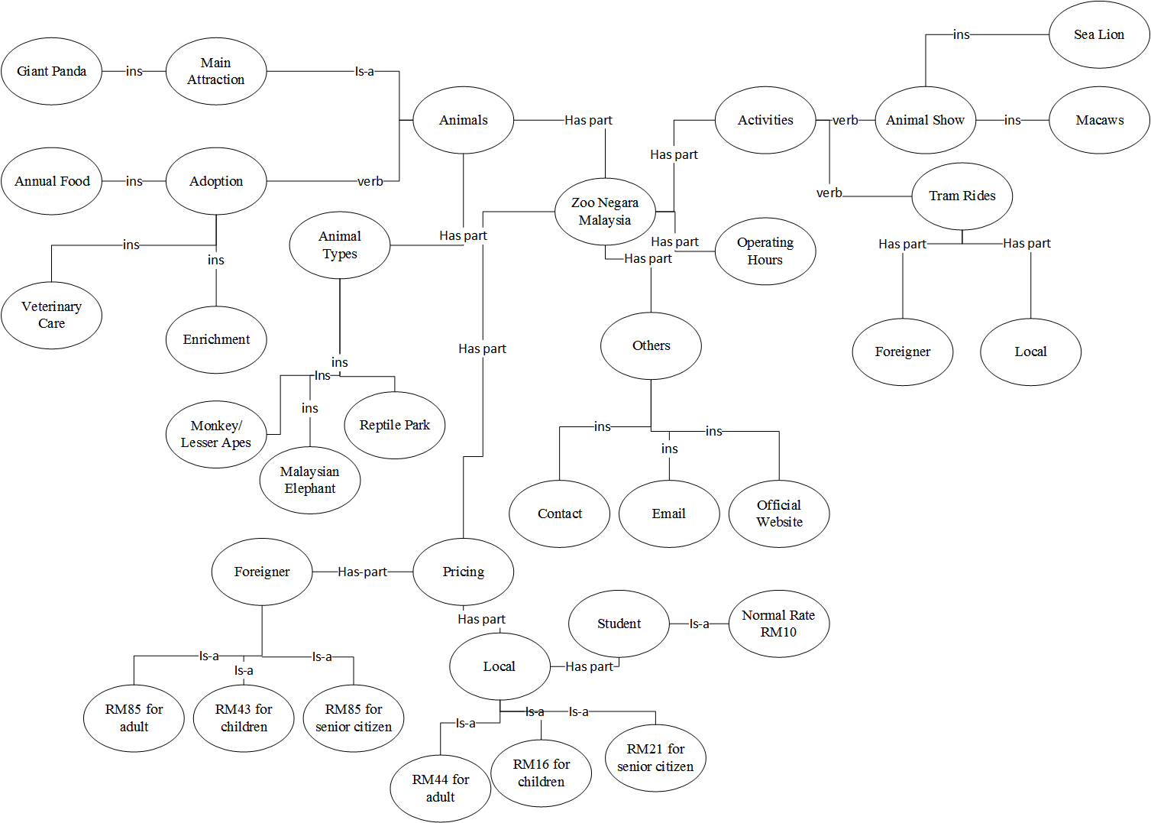

## Parent frames

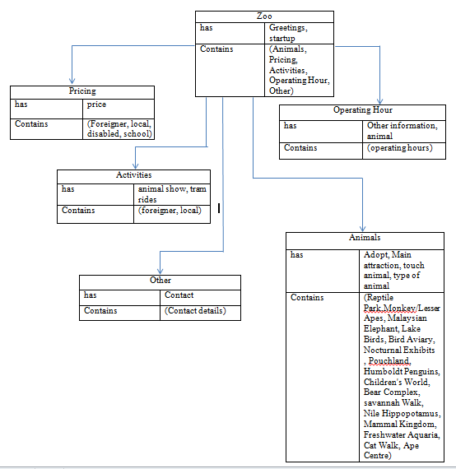

## Child frames of Animals frame

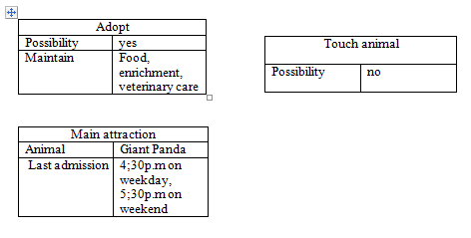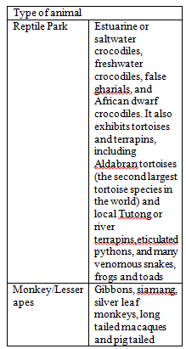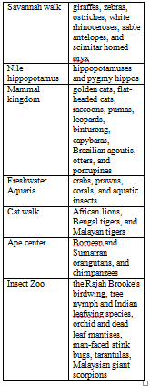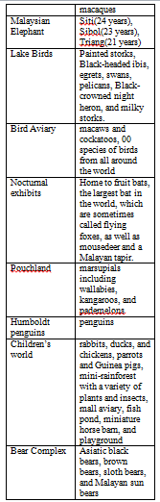

## Child frames of Pricing frame

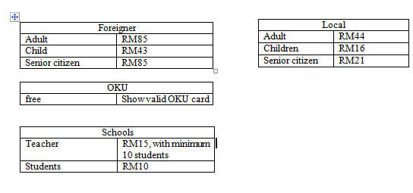

## Child frames of Activities frame

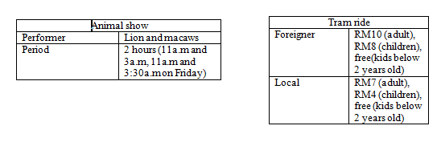

## Child frame of Other frame

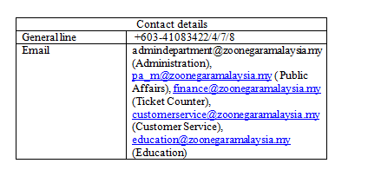

## Child frames of Opening Hour frame

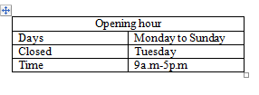

# IMPLEMENTATION

## Test Plan

|  |  |  |
| --- | --- | --- |
| TEST CASE | EXPECTED RESULT | ACTUAL RESULT |
| Menu |  |  |
| Displays “Hello my name Cola, I'm an expert in the field of Zoo, specialize in Zoo Negara Malaysia. Can I know what is your name?” | None | As expected |
| Insert name | Displays “Hi [name], can I know what you wanted to know about the Zoo?  1. Animals  2. Pricing  3. Activities  4. Operating Hours  5. Others” | As expected |
| Animals |  |  |
| Insert   * animal * animals * 1 | Displays “What do you want to know about the animal?” | As expected |
| Insert   * Is it possible to adopt an animal? * Is it possible to adopt animal? | Displays “Yes, it is possible to adopt animal by maintaining its annual food, enrichment and veterinary care.” | As expected |
| Insert “What is the main attraction of the zoo?” | Displays “The main attraction of the zoo now is the Giant Panda. The last admission to the giant panda conversation center is 4.30PM on weekday and 5.30PM on weekend.” | As expected |
| Insert   * How many animal are there in the zoo? * The zoo has how many animal? * How many species of animal are there in the zoo? * how many animal exhibit in the zoo? | Displays “There are various type of animal exhibit in the zoo, which exhibits you are interested with?  1. Reptile Park  2. Monkey/Lesser Apes  3. Malaysian Elephant  4. Lake Birds  5. Bird Aviary  6.Nocturnal Exhibits  7. Pouchland  8. Humboldt Penguins  9. Children's World  10. Bear Complex  11.savannah Walk  12.Nile Hippopotamus  13.Mammal Kingdom  14.Freshwater Aquaria  15.Cat Walk  16.Ape Centre  17. Insect Zoo” | As expected |
| Insert   * 2 * apes * monkey * monkey/lesser apes | Displays “he zoo's collection of monkeys and lesser apes include gibbons, siamang, silver leaf monkeys, long tailed macaques, and pig-tailed macaques” | As expected |
| Insert   * 3 * elephant | Displays “The Malaysian Elephants exhibit is home to three Malaysian elephants: Siti (24 years), Sibol (23 years) and Triang (male, 21 years), which have all been in the zoo since they were very young.” | As expected |
| Insert   * lake birds * lake bird * 4 | Displays “The Lake Birds exhibit includes painted storks, Black-headed ibis, egrets, swans, pelicans, Black-crowned night heron, and milky storks” | As expected |
| Insert   * 5 * bird aviary | Displays “With over 100 species of birds from all around the world, walk in Aviary is also home to a variety of free flying birds. The Birds Photo Corner in the aviary lets visitors take souvenir photos with a variety of macaws and cockatoos on weekends.” | As expected |
| Insert   * 6 * nocturnal exhibits * noctural | Displays “hese indoor exhibits are home to fruit bats, the largest bat in the world, which are sometimes called flying foxes, as well as mousedeer and a Malayan tapir.” | As expected |
| Insert   * reptile park * 1 * Reptile | Displays “he Reptile Park has both indoor and outdoor exhibits, and includes estuarine or saltwater crocodiles, freshwater crocodiles, false gharials, and African dwarf crocodiles. It also exhibits tortoises and terrapins, including Aldabran tortoises (the second largest tortoise species in the world) and local Tutong or river terrapins. Snakes in the collection include reticulated pythons, and many venomous snakes.  The Amphibian World center at the Reptile Park has a variety of frogs and toads that originate from various habitats in Malaysia.” | As expected |
| Insert   * 7 * Pouchland | Displays “Pouchland is home to a variety of marsupials including wallabies, kangaroos, and pademelons.” | As expected |
| Insert   * 8 * Penguin | Displays “This exhibit is home to Humboldt penguins.” | As expected |
| Insert   * 9 * children * children's world | Displays “Children's world houses a variety of mostly domestic animals including rabbits, ducks, and chickens running around freely, as well as parrots and Guinea pigs. It includes a mini-rainforest with a variety of plants and insects, as well as a small aviary, fish pond, miniature horse barn, and playground.” | As expected |
| Insert   * 10 * bear * bear complex | Displays “The Bear Complex is home to several types of bear including Asiatic black bears, brown bears, sloth bears, and Malayan sun bears.” | As expected |
| Insert   * 11 * savannah * savannah walk | Displays “The Savannah Walk is one of the largest open concept exhibits in the zoo, and is home to giraffes, zebras, ostriches, white rhinoceroses, sable antelopes, and scimitar horned oryx.” | As expected |
| Insert   * 12 * Hippopotamus * Nile Hippopotamus | Displays “This exhibit is home to hippopotamuses and pygmy hippos. The zoo has three Nile hippopotamuses: Duke, Kibu, and Chombie. Chombie was born at the zoo” | As expected |
| Insert   * 13 * mammal * mammal kingdom | Displays “The Mammal Kingdom exhibit includes golden cats, flat-headed cats, raccoons, pumas, leopards, binturong, capybaras, Brazilian agoutis, otters, and porcupines.” | As expected |
| Insert   * 14 * aquaria * freshwater aquaria | Displays “Zoo Negara's Tunku Abdul Rahman Aquarium is the first ecological-based freshwater aquarium that highlights the Malaysian river and wetlands. The aquarium features fish that are commonly seen in Malaysian rivers, as well as rare and endangered species including invertebrates such as crabs, prawns, corals, and aquatic insects” | As expected |
| Insert   * 15 * cat walk * cat | Displays “The Cat Walk features African lions, Bengal tigers, and Malayan tigers” | As expected |
| Insert   * 16 * ape center * ape | Displays “The Ape Centre is home to Bornean and Sumatran orangutans, and chimpanzees.” | As expected |
| Insert   * 17 * insect * insect zoo | Displays “The Insect Zoo is the latest attraction at Zoo Negara and displays more than 200 species of insects from around the world. This exhibit is the first of its kind in the country and the largest in the region.  Among the insects at the zoo are butterflies such as the Rajah Brooke's birdwing, tree nymph and Indian leafwing species, orchid and dead leaf mantises, man-faced stink bugs, tarantulas, Malaysian giant scorpions and many more. According to the zoo, "The Insect Zoo is working on compiling a unique collection of insects including the largest and longest butterfly in the world.”” | As expected |
| Insert   * Is it possible to touch the animal? * Is that possible to touch the animal? | Displays “No, depends on condition, but usually zoo keeper not allow the visitor to touch the animal.” | As expected |
| Pricing |  |  |
| Insert   * 2 * price * pricing * ticket price | Displays “Are you foreigner or local? Or are you a disabled person? Or you're student/teacher with letter from school?  Please note that people with MyKad are consider as local.” | As expected |
| Insert   * foreigner * not local * tourist | Displays “The pricing for adult is RM85, children is RM43 and senior citizen is RM85” | As expected |
| Insert   * local * with mykad | Displays “For local, the price for adult is RM44, children is RM16 and for senior citizen is RM21” | As expected |
| Insert   * oku * disabled | Displays “You're welcome to the zoo with free of charge. But please show your valid OKU card to the counter.” | As expected |
|  |  |  |
| Insert   * school * teacher * student | Displays “Normal rate for student is RM10, if you're teacher with at least 10 student coming with you, the rate is RM15.” | As expected |
| Activity |  |  |
| Insert   * 3 * activity * activities | Displays “he zoo has two major activity.  1. Multi - Animal Show  2. Tram Rides | As expected |
| Insert   * multi - animal show * animal show | Displays “The main two "performer" of the show are sea lion and macaws. The show has 2 performance hour, which is 11AM and 3AM while for Friday is 11AM and 3.30AM.  The show might be cancelled without prior notice” | As expected |
| Insert   * tram ride * tram rides * ride * rides | Displays “The tram ride available at zoo with extra charge, can I know are you local or foreign?  Please note that people with MyKad are considered as local” | As expected |
| Insert   * foreigner * without mykad | Displays “The rate for tram ride is RM10 for adult and RM8 for children. Kids below 2 years old are free. Do you want to back to menu? Or you want to quit the program?” | As expected |
| Insert   * local * with mykad | Displays “The price for tram ride is RM7 for adult and RM4 for children, kids below 2 years old are free. Is there anything else you want to know?” | As expected |
| Others |  |  |
| Insert   * 5 * other * others | Displays “What do you want to ask about the zoo?” | As expected |
| Insert   * How to contact the zoo? * What is the contact number of the zoo? * What is the email of the zoo? | Displays “For any enquiries, please contact the general line at +603-41083422/4/7/8 or email the following department  Administration, admindepartment@zoonegaramalaysia.my  Public Affairs, pa_m@zoonegaramalaysia.my  Ticket Counter: finance@zoonegaramalaysia.my  Customer Service: customerservice@zoonegaramalaysia.my  Education: education@zoonegaramalaysia.my  Is there anything else I can assist you?” | As expected |
| Operating Hours |  |  |
| Insert   * 4 * opening hour | Displays “The zoo open Monday to Sunday from 9AM until 5PM, and the zoo closed on Tuesday except on Malaysian school holiday and public holiday.i hope this information really helpful.do you want to know about animal?” | As expected |
| Insert “no” | Displays “its ok.but i still can give u other information.would you like to know about” |  |
| Out of scope |  |  |
| Insert “*” | Displays “Sorry, I don't know what you mean.  Please select from one of the option below.  1. Animals  2. Pricing  3. Activities  4. Operating Hours  5. Others” | As expected |

## User manual

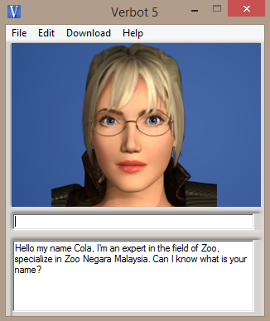

MAIN MENU

The Verbot system will start the conversation with greetings like this. The user has to enter their name to precede the process.

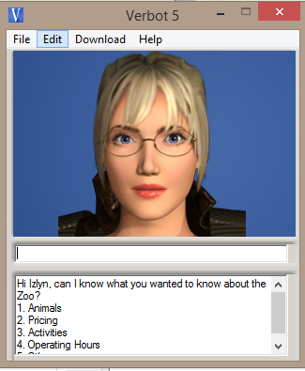

SEARCH FOR INFORMATION

The Verbot system allows the user to choose which one is related to the question of interest. They may either enter the number or any words related to the specific parts.

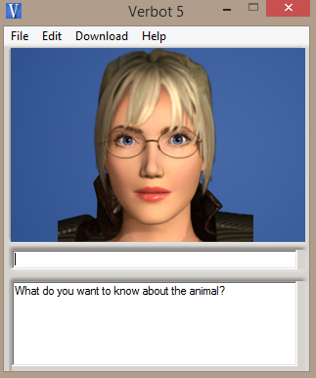

QUESTION REGARDING ANIMALS

If the user chooses number 1 as in previous question, the system will display this. The user may insert the question.

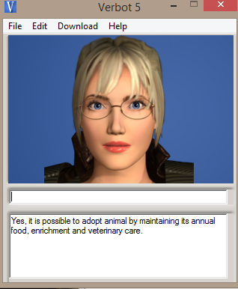

INFORMATION REGARDING ANIMALS

The system answers the question inserted by the user.

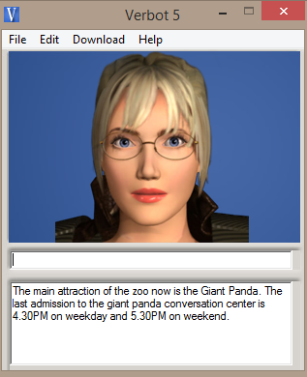

MAIN ATTRACTION OF ZOO

The system answers the question asked by the user about main attraction of Zoo. This is included in the part of Animals information.

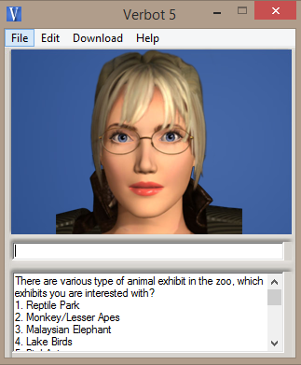

TYPE OF ANIMAL EXHIBIT IN ZOO NEGARA

The system displays type of animals with different numbers. The user has to choose which part they want to know.

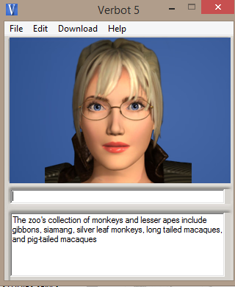

MONKEY/LESSER APES

The system displays information about monkey or lesser apes as requested by the user.

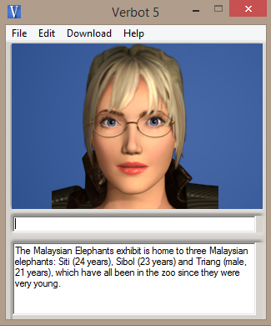

MALAYSIAN ELEPHANTS

The system displays information regarding elephants in Zoo Negara

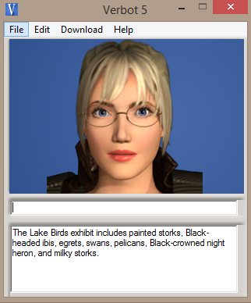

LAKE BIRDS

The system displays about lake birds as chosen by the user.

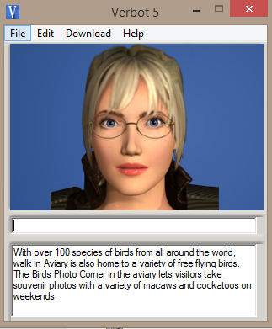

BIRD AVIARY

The system displays information about bird aviary to the user.

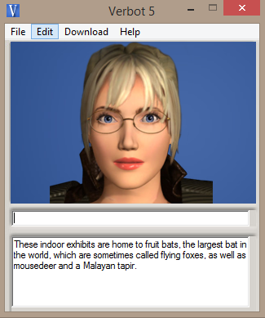

NOCTURNAL EXHIBITS

The system displays those animals who are nocturnal exhibits as requested by user.

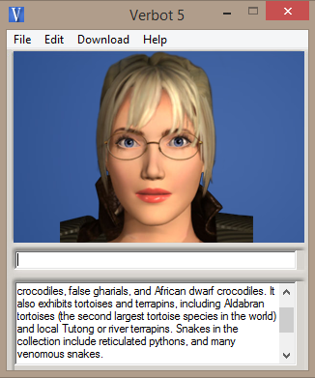

REPTILE PARK

The system displays information about animals which are grouped under reptiles species at reptile park.

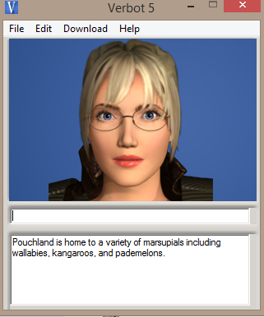

POUCHLAND

The system displays about Pouch land as user requests.

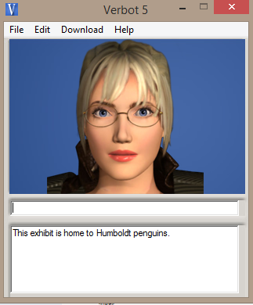

HUMBOLDT PENGUINS

The user requests to know about the penguins and the system will automatically display this.

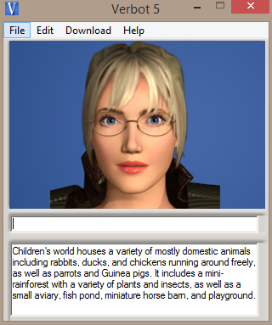

CHILDREN’S WORLD

The system shows specific information regarding Children’s World in Zoo Negara.

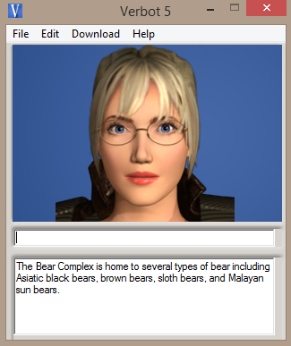

BEAR COMPLEX

The system indicates some information of Bear Complex in Zoo Negara.

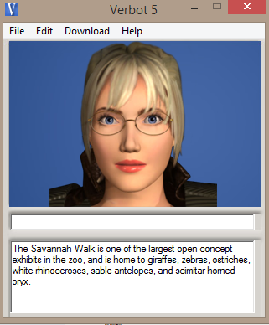

SAVANNAH WALK

The system shows about the park in Zoo Negara which called Savannah Walk to the user.

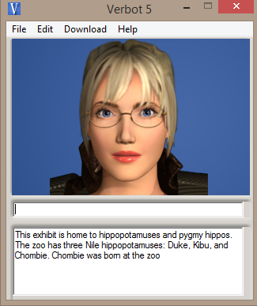

NILE HIPPOPOTAMUS

As requested by user, the system manages to display the information about the animal called Nile hippopotamus.

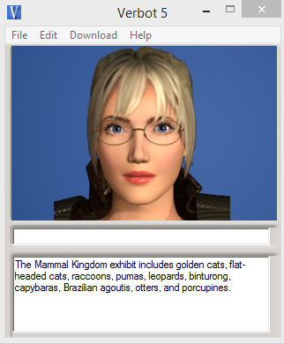

MAMMAL KINGDOM

The system displays the specific mammals animals as requested by user.

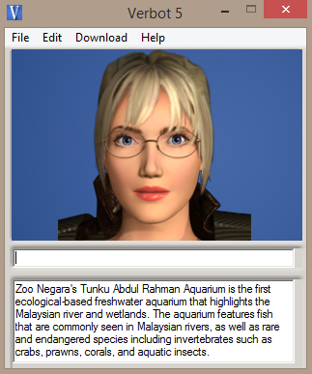

FRESHWATER AQUARIA

The system displays about freshwater aquaria with some additional information as wanted by the user.

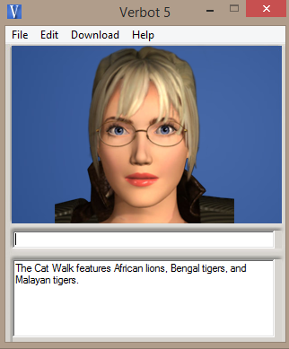

CAT WALK

If the user chooses to know about cats, they would want the system to displays information about it.

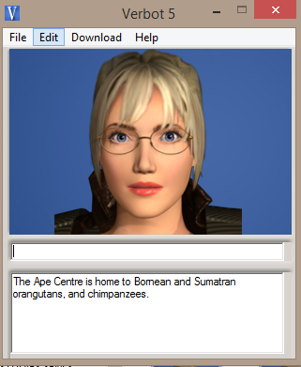

APE CENTER

The system indicates information as requested by the user about apes in ape centre.

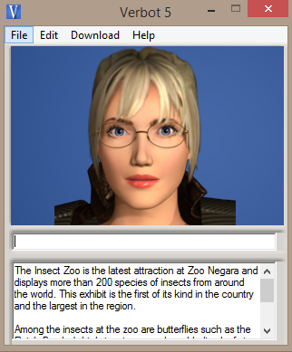

INSECT ZOO

The system displays information about all kinds of insect available in the Zoo Negara.

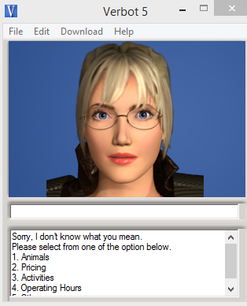

QUESTION OUT OF SCOPE

If the user tends to insert question which is out of scope, the system will ask the user to choose other option provided by the system.

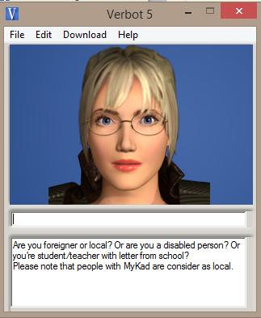

PRICING

The user might want to know the price to enter the Zoo Negara. The system will displays this before proceed to the real pricing.

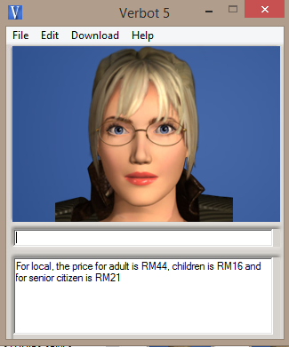

PRICING FOR LOCAL

If the user is local, the system will display the real pricing for them.

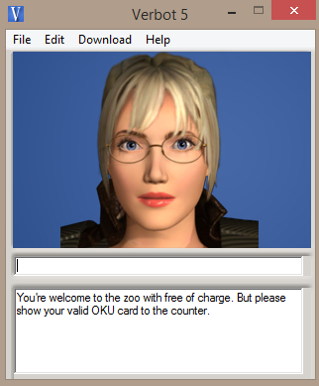

PRICING FOR OKU

The pricing for OKU will be displayed as requested by the user.

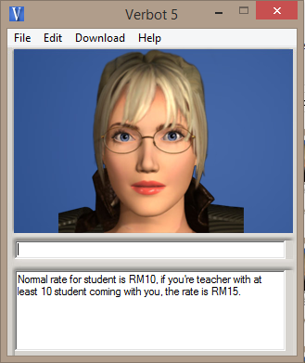

PRICING FOR SCHOOL

The pricing for students or teacher will be displayed by the system as requested.

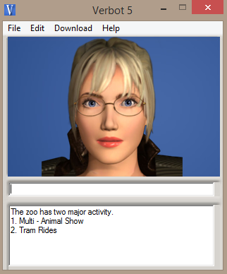

ACTIVITIES

If the user interested to know about the activities in Zoo Negara, the system will show to them the list for them to choose.

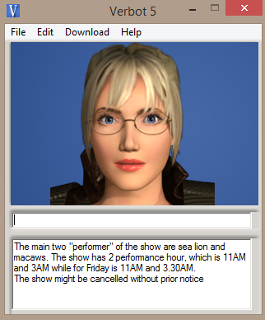

MULTI-ANIMAL SHOW

The information will be displayed if the user chooses to know about multi-animal show.

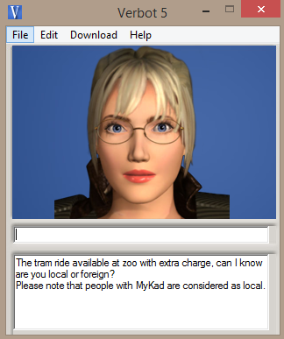

TRAM RIDE

This is the information about tram ride activity in Zoo Negara shows by the system as the user wanted to know.

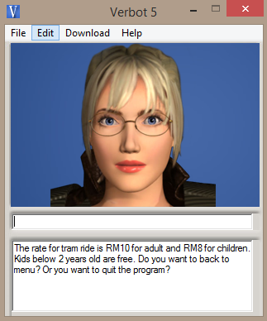

TRAM RIDE FOR FOREIGNER

The pricing for tram ride for foreigner displayed to the user who requests for it.

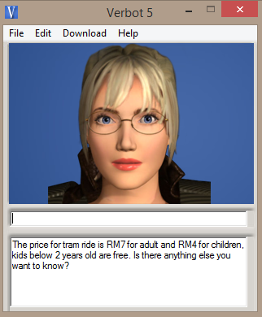

TRAM RIDE FOR LOCAL

The pricing for tram ride for local displayed to the user who requests for it.

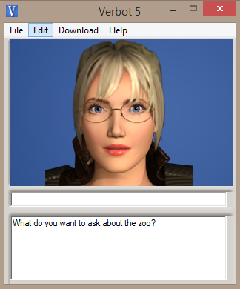

OTHERS INFORMATION

The system will ask the user whether they need to know other information that might be out of the scope.

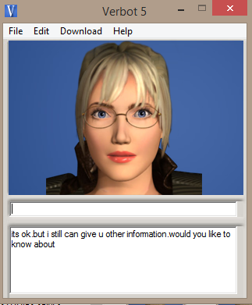

USER NOT INTERESTED TO ASK

If the user tells that they no longer interested to ask more question, the system will displays this.

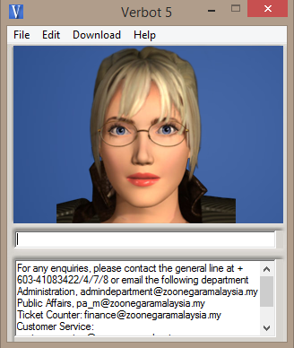

CONTACT ZOO NEGARA

If the user tends to have Zoo Negara contact details, the system will display all details regarding about it.

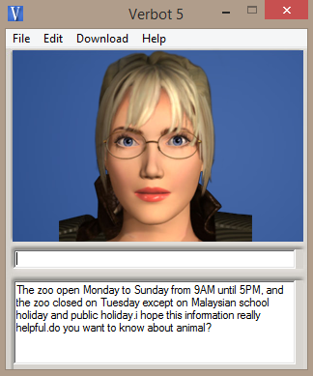

OPERATING HOURS

The system will shows to the user information about Zoo Negara operational time.

# EVALUATION OF PROTOTYPE

## Performance and achievement

The system provides various parts of information available. The user can choose any of them and ask in details. The system manages to answer most of question related to parts provided.

## Further Enhancement

* The developer shall enhance system knowledge base so the system enables to detect others word and sentence with same meaning
* The system shall allow user to proceed with another question instead of try to go to start up again.

## Conclusion

The Expert system is a way to make everyone’s life easier because it holds almost all information of the department. It reduces manpower and tasks among staffs. It also helps tourists in needs of information regarding Zoo Negara. Even there are some limitations bothered the system, it still can be improved over time.

# REFERENCES

Huntbach, M., 2016. *Artificial Intelligence I.* [Online]   
Available at: http://www.eecs.qmul.ac.uk/~mmh/AINotes/AINotes4.pdf  
[Accessed 2 April 2016].

Malaysia, Z. N., 2016. *Welcome To Zoo Negara.* [Online]   
Available at: http://www.zoonegaramalaysia.my/  
[Accessed 10 April 2016].

Verbot, 2014. *Chatterbox Challenge Awards using Verbots.* [Online]   
Available at: http://verbots.blogspot.my/  
[Accessed 30 March 2016].

# APPENDICES

## Installation manual

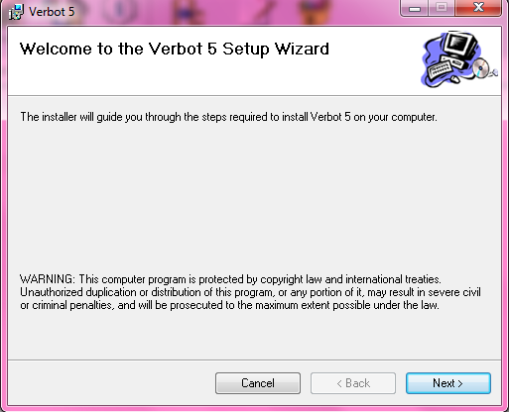

This is the first step to install the Verbot. The user has to click “Next” button to precede the installation.

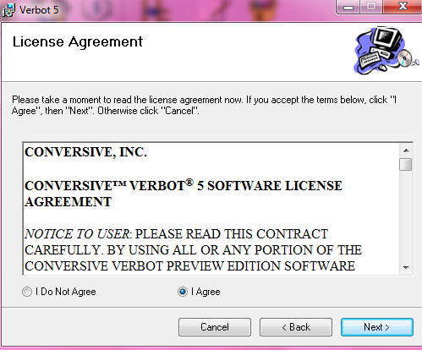

The user has to read the agreement. After that, they have to tick on the “I Agree” radio button then click the” Next” button for next process.

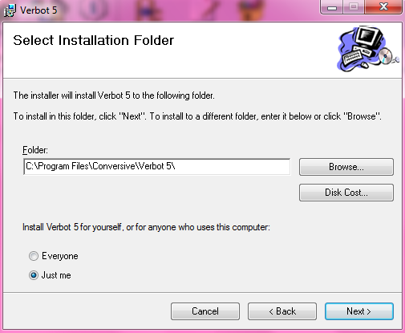

The user then has to choose any folder they want to save the Verbot program files. Otherwise, just ignore it because the folder has been chosen automatically. The user also may choose either to install the Verbot for self or everyone by ticking on the radio button provided. Click “Next” button for further process.

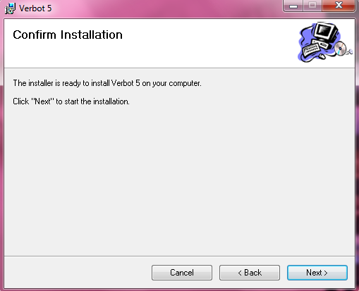

This is to ensure the user has confirmed with the previous process. Click “Back” button to view or edit any processor click “Next” button to start the installation of Verbot.

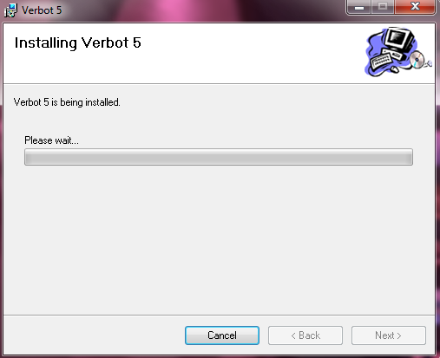

The Verbot is finally installed after the loading is done. Click “Cancel” button if the user tends to stop the installation.

## Source Code

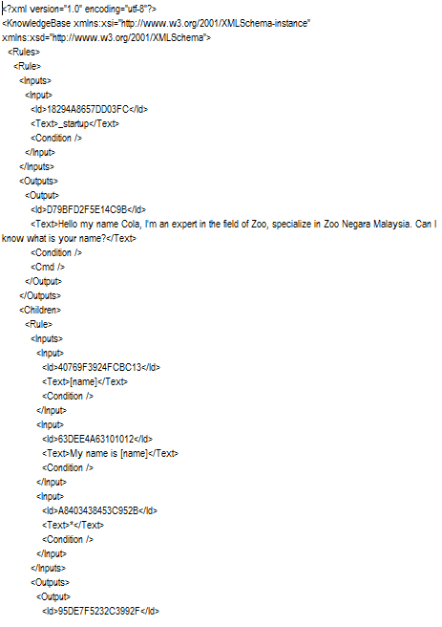 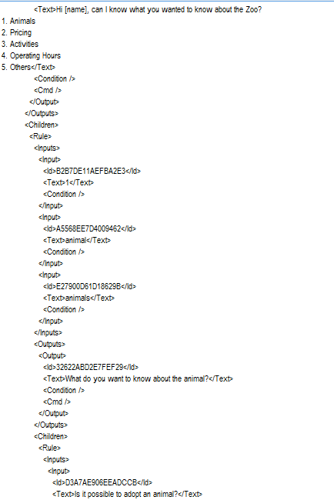

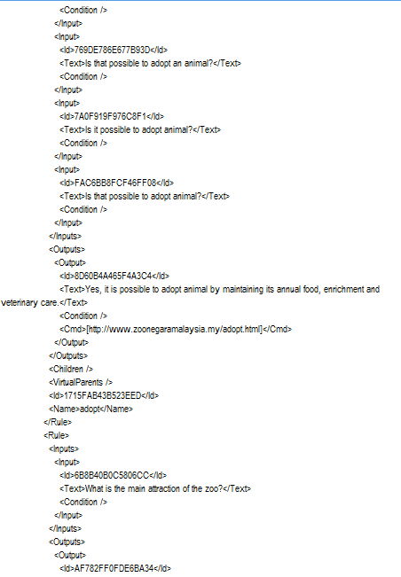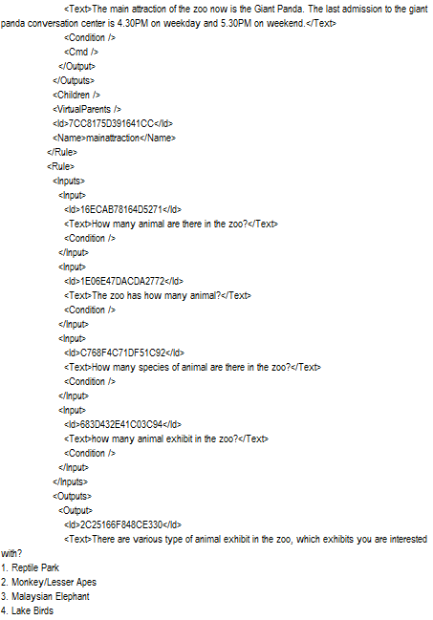

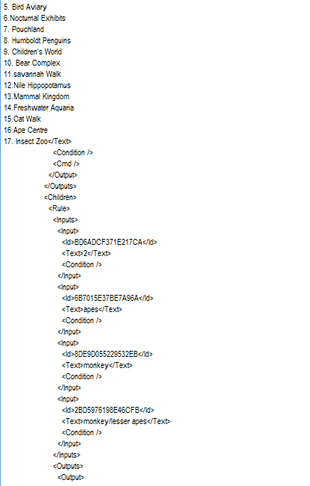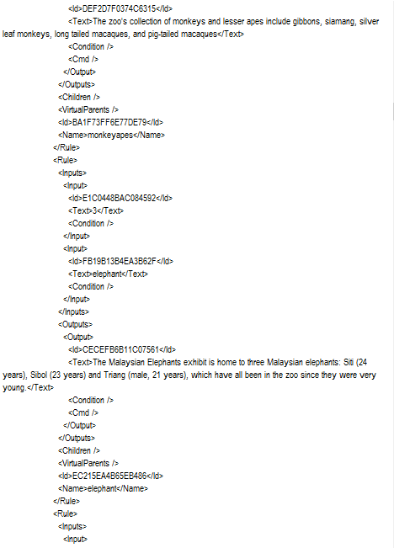

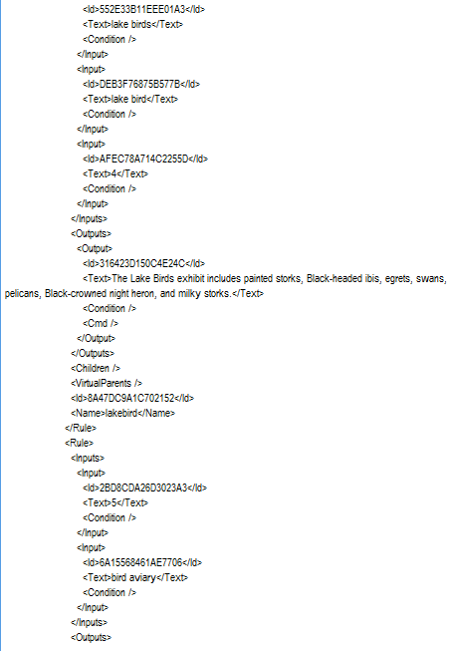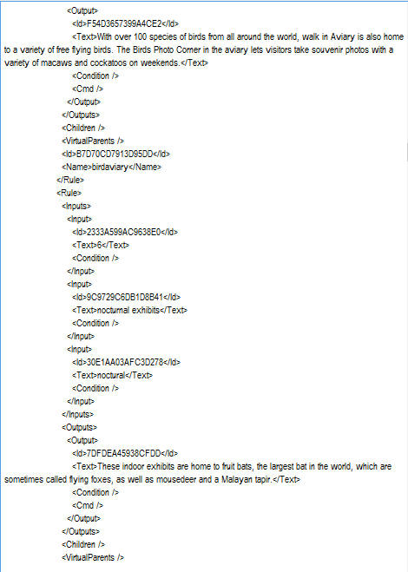

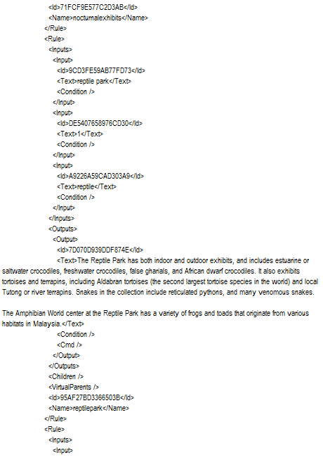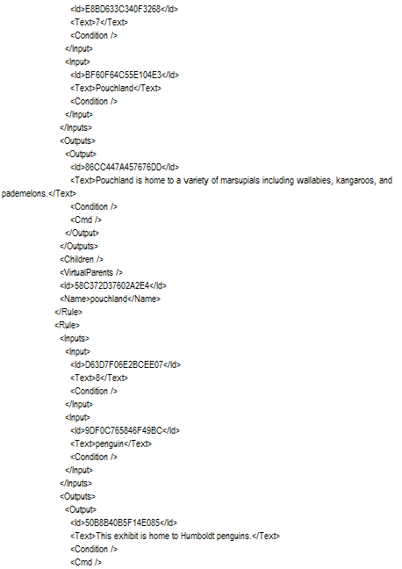

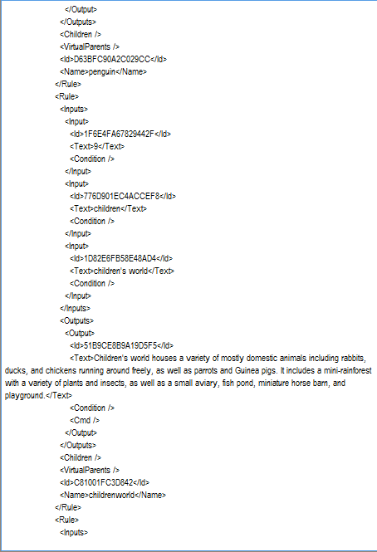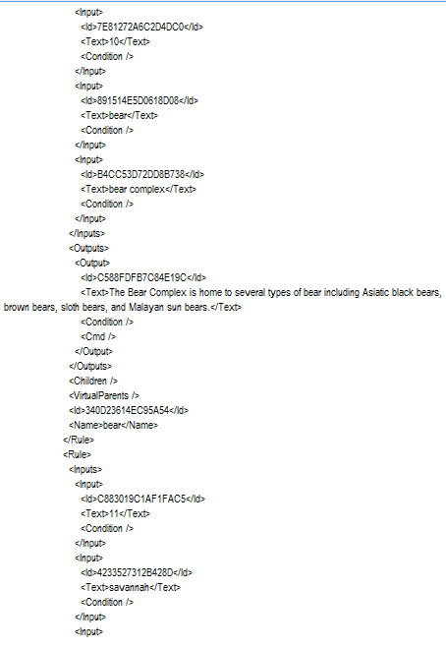

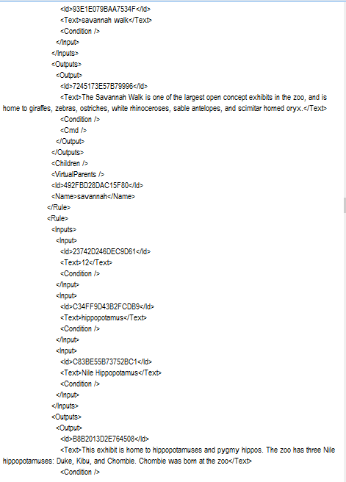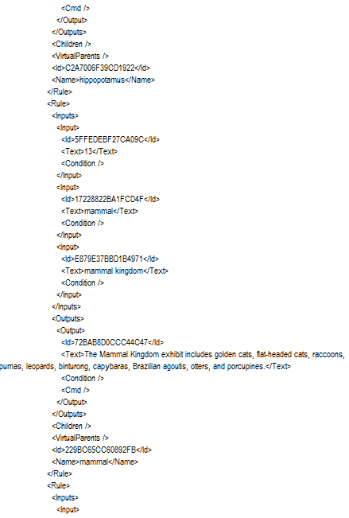

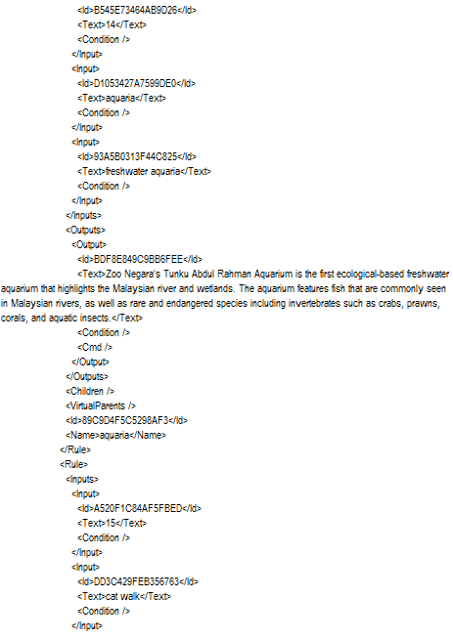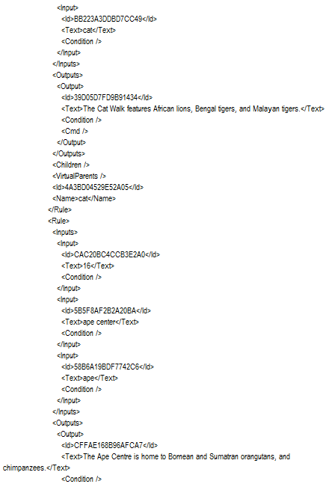

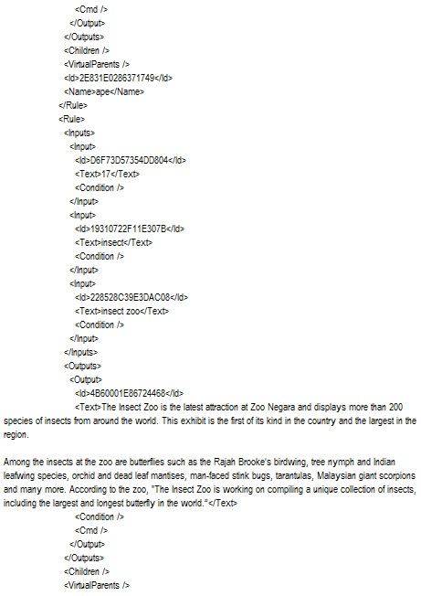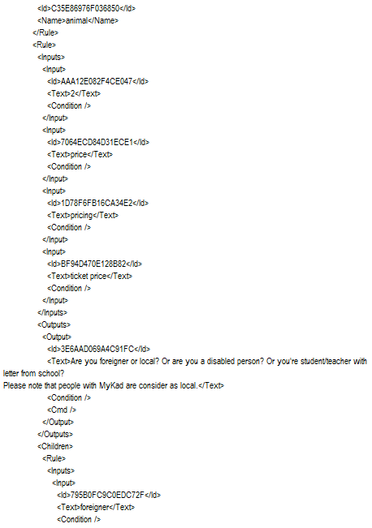

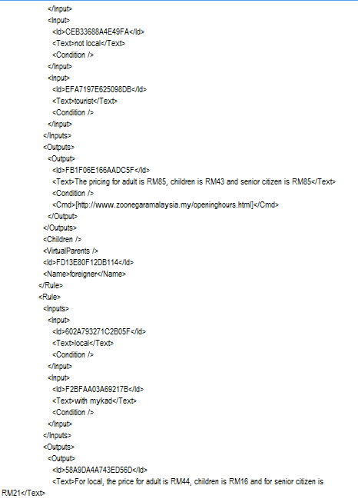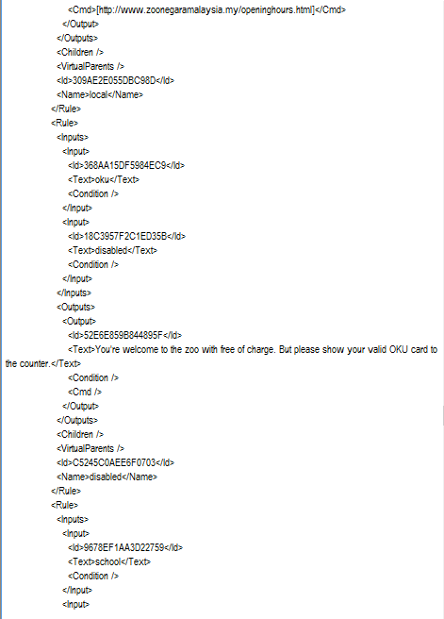

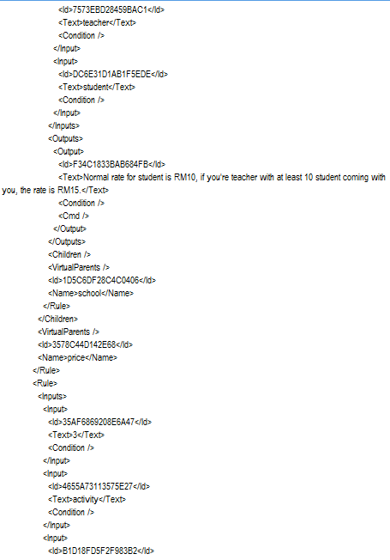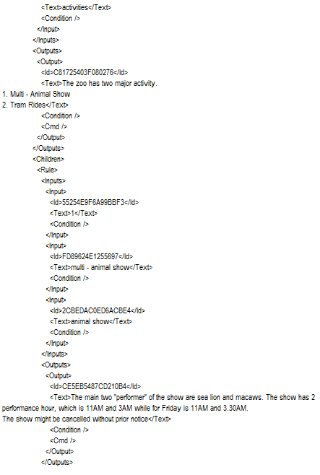

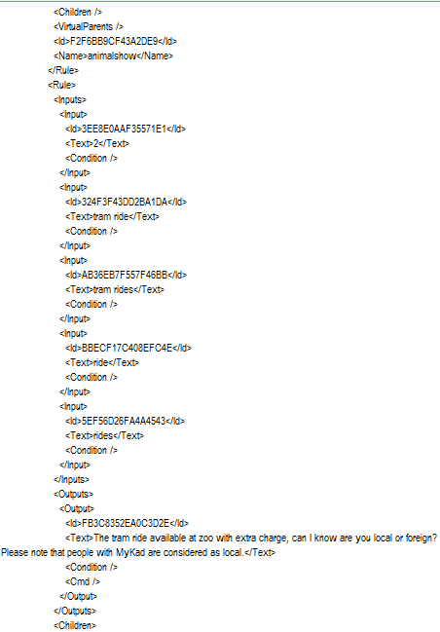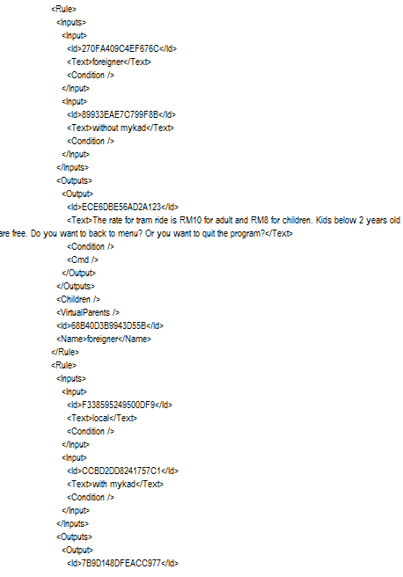

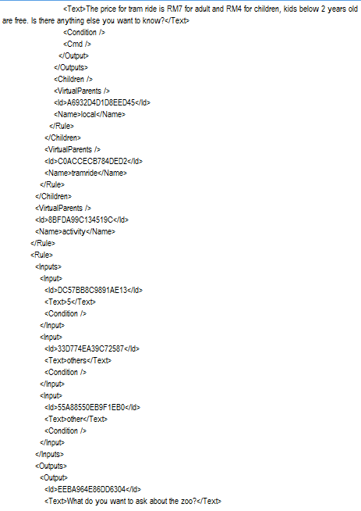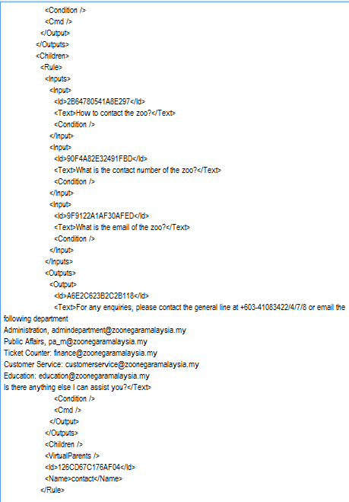

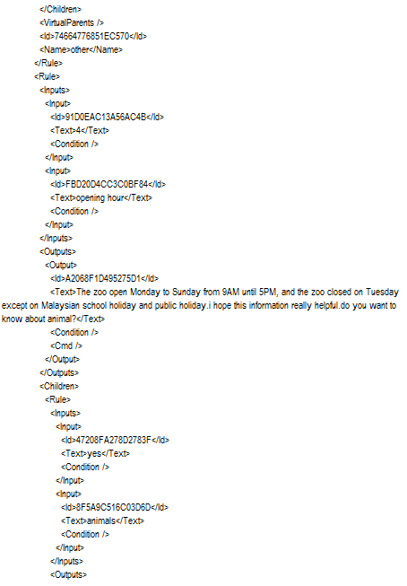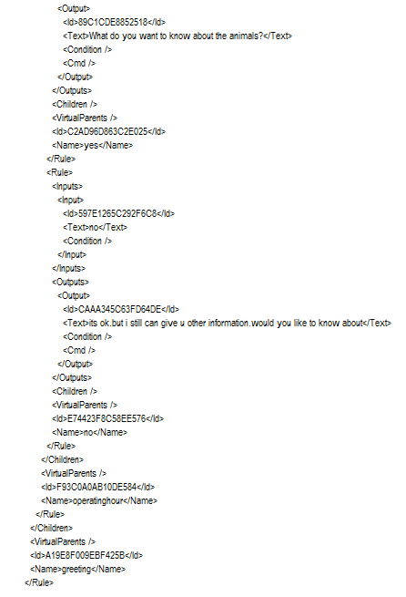

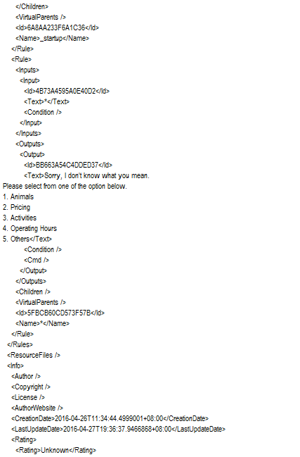

## Workload Matrix

|  |  |  |  |
| --- | --- | --- | --- |
|  | SITI NURIZLYN | NG HO KIT | LOH YEANI |
| **IDENTIFICATION** |  |  |  |
| INTRODUCTION | 33 | 33 | 33 |
| PROBLEM STATEMENT | 33 | 33 | 33 |
| **PROBLEM SPECIFICATION** | 33 | 33 | 33 |
| **KNOWLEDGE ACQUISITION** | 33 | 33 | 33 |
| **KNOWLEDEGE REPRESENTATION** | 33 | 33 | 33 |
| **IMPLEMENTATION** |  |  |  |
| TEST PLAN | 33 | 33 | 33 |
| USER MANUAL | 33 | 33 | 33 |
| **EVALUATION OF PROTOTYPE** |  |  |  |
| PERFORMANCE | 33 | 33 | 33 |
| FURTHER ENHANCEMENT | 33 | 33 | 33 |
| CONCLUSION | 33 | 33 | 33 |
| **VERBOT** | 33 | 33 | 33 |
| TOTAL MARKS | 100% | 100% | 100% |

## Appendices

### Interview list of question

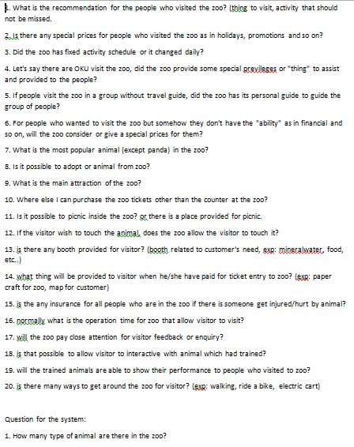

### Interview form from Zoo Negara

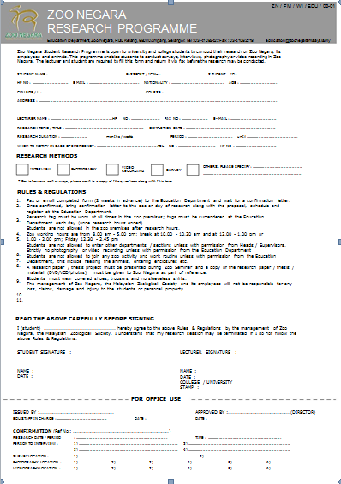

### Pictures of team project with expert system in Zoo Negara

